This course information and booking form includes the following:-
- The booking form - this is the first part of the document
- What happens next, how the booking process works
- Course, accommodation and catering information
- Terms & Conditions

Booking Form
To help us confirm your booking, please complete the form below and email it to office@midlandgliding.club. Delete or over-type any examples and include as much information as you would like😊. Any questions, just call us on 01588 650206.
When we confirm your booking, we will send you a confirmation and an invoice for the course and the deposit fee of £100.00.
Please be sure to include your phone number so that we can contact you to finalise your booking.
Name & Contact Details
Full Name: | Title, Mr, Mrs, Miss, Ms:  First Name:  Last Name:
Address:
Post Code:
Email Address:
Telephone: | Home:  Mobile:
Date of Birth (for our records)
Membership
(delete as appropriate) | - I will join the Club as an Associate Member as part of the course. (This is the normal option)  - I will join the Club before the course as a Full or Associate Member of the Club  - I am an existing Full Member or Associate Member of the Club
I would like to book on the following course:
For availability, see: https://www.midlandgliding.club/rota/CourseSchedule2024.htm
First Choice: | Course number:  Dates:  (See below for dates and prices)
Second Choice: | Course number:  Dates:  (See below for dates and prices)
I would like to book the following accommodation:
First choice:  (delete as appropriate) | Private Room  Half en suite  Full en suite  Camping  No accommodation
Second choice:  (delete as appropriate) | Private Room  Half en suite  Full en suite  Camping
About your holiday:
What is the purpose of your holiday?  (delete as appropriate) | Try something different?  Learn to glide?  Learn a new gliding skill?  Just have a fun time?
How would you describe where you are on your gliding journey?  (delete as appropriate) | I am looking forward to glide for the first time!  Working towards going solo?  Working towards Bronze?  Completing cross-country endorsement?  Completing Silver?  Experienced glider pilot
If there is anything else we should know?  (these are suggestions. Delete and replace as appropriate) | I am a commercial pilot and want to fly the real thing again!  Hours? Last flight?  Can my wife bring her horse?  I am under the age of 18 and will be accompanied by my parents or responsible adult? Under the age of 18 we require a parental consent form to be completed.
Taking advantage of the discounts we offer?
Early Payment: | If you pay in full by the end of February, we will discount your accommodation and course fee by 10%. The discount is applied to the net price after any other discounts.
Associate & Full Members with annual membership | Associate & full members with annual membership received a 25% discount on the course fee.
Have you been to the Mynd before? | If you have, please let us know when.
Where did you find us?
(delete as appropriate) | - British Gliding Association  - Bing search  - Google search  - Facebook  - Flyer – Learn to fly guide  - My Shrewsbury  - Passing by  - Pilot Magazine  - Recommendation – word of mouth  - Shropshire Magazine  - Other
Administration Stuff
Membership Number:
Course Number:
Room Number:
Invoice Numbers:
Date & Signature
Date
Signed
(But only if submitted on paper. If you send by email a printed name will be deemed to be your signature)

What Happens Next
When we receive you booking form, we will check it and confirm availability. If we have any questions we will call or email you.
We will then send you confirmation of your booking. We will send you two “click to pay” invoices. One is for the for the depost of £100. The other is for the total value of your course less the deposit of £100.
You can make payment by “click to pay” invoices or by using a credit or debit card by telephoning the office. The Club no longer accepts cheques as there is no longer a bank in Chruch Stretton. That is progress.
Once we receive payment for the deposit, your booking is secure.
If you wish to take advantage of the 10% early booking and payment discount, call or email the office before the 28th of February, and we can take payment over the phone or send you a “click to pay statement” including a 10% discount. It is up to you.

Course, Accommodation & Catering Information
Courses
Over the decades, the Club has been offering courses, and the maximum number of students to instructor ratio has reduced. There is a balance between the ability to progress, the amount of flying, running the airfield and the price. This year we are offering:
- Premium - maximum student to instructor ratio of 3:1.
- Standard - maximum student to instructor ratio of 4:1
- Solo – share a single seater with one other
The Solo course is for solo pilots who want to use the week to fly alone (aside from a couple of check ights at the start of the week), to hone their skills or just for the sheer pleasure of it. To qualify for this course, you will need a Bronze C badge or at least twenty solo fights from the Mynd in the two years before the course.

Schedule
You can find the schedule and availability by following the link below:-
https://www.midlandgliding.club/rota/CourseSchedule2024.htm

More information on the following pages
- Course prices
- Course discounts
- Accommodation prices
- Catering
- Terms & Conditions

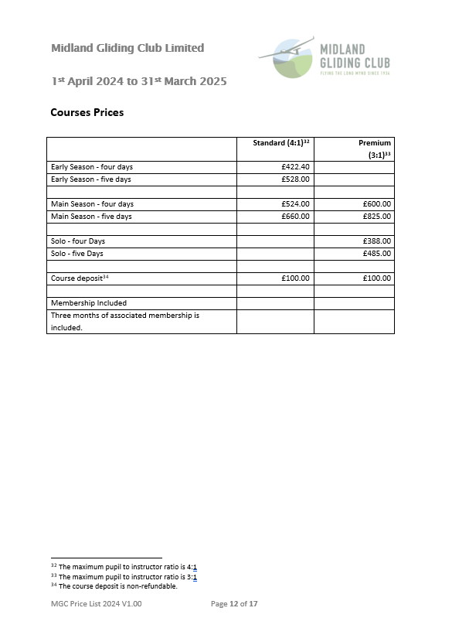
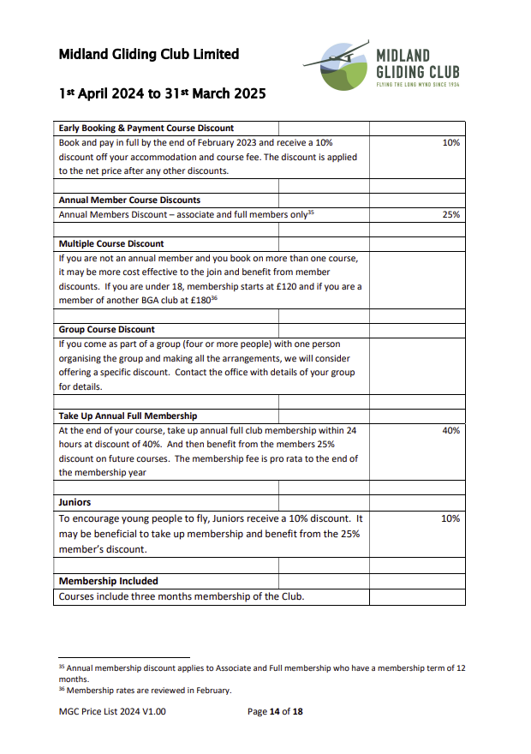
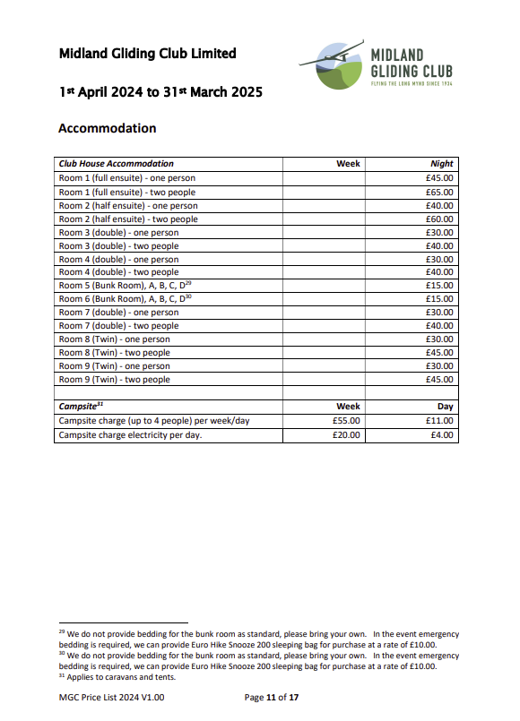

Catering
On site catering is provided by a separate business operated by Helen Crowson. A full range of food is offered throughout the day from breakfast to evening meals. Details are available from catering@midlandgliding.club

Terms and Conditions
Definitions and Interpretation
In the Booking Form and in these Terms and Conditions:
‘you’ and ‘your’ refer to the person making the booking (or, in the case of a person under the age of 18 years, the person attending the course);
‘we’, ‘our’ and ‘Club’ refer to the Midland Gliding Club Limited, a company registered in England and Wales (company registration number IP11889R), the registered office of which is at the Airfield, The Long Mynd, Church Stretton, Shropshire SY5 6TA.
‘in writing’ includes a message sent by email

1. The Booking
The person wishing to attend the course should complete the Booking Form, but if the person is under the age of 18 years, the Booking Form should be completed by his or her parent or guardian, making it clear who will be attending the course giving his or her name and address and age.
A reservation on one of our holiday courses is confirmed when we send you a note in writing that the booking has been accepted.
We reserve the right to decline or accept a booking.
The reservation is not transferable.

2. Payment
A deposit of £100 towards the course fee is payable as soon as your booking has been confirmed.
The balance of the course fee is payable on or before the 28th day before the start date of your course.

3. Our commitment
We aim to provide you with as much instruction and flying time as is reasonably safe and practical within our normal flying operations. However, gliding is always weather dependent and so we cannot give any commitment on the amount of flying time you will be offered. If adverse weather conditions prevent flying operations, detailed ground briefings will be given along with use of our simulator, if it is available.

4. Membership of the Club
You are required to be a member of the Club for the duration of your course. The course fee includes three months membership of the Club. The Application Forms for membership are available on our website and a paper version has to be submitted. As a member, you will be bound by the Rules of the Club (both the Statutory Rules and all our rules and procedures relating to our flying operations), all of which are available on our website.

5. Cancellation or variation of the terms of the reservation
We reserve the right to cancel the reservation at any time for reasons beyond our reasonable control. We will do so in writing as soon as circumstances reasonably allow this.
We also reserve the right to cancel your reservation if you do not pay the balance of the course fee by the 14th day before the start date of the course.
We will do all we reasonably can to meet any variation of your reservation which you want to make provided you request this in writing more than 28 days before the start date of your course.
We cannot make any variation of your reservation 28 days or less before the start date of your course.
In all cases of cancellation, the Club is not liable to pay any compensation or reimburse expenses.

6. Effect of cancellation or variation of the terms of the reservation
If we have to cancel your reservation under paragraph 5 above for reasons beyond our control, we will offer you a place on another course, if one is available, or a full refund of the payment you have made for the course, if you prefer.
If we cancel your reservation under paragraph 5 because the balance of the course fee has not been paid, the balance will still be payable. However, if we are able to fill the vacancy, we will waive payment of the balance but the deposit will be forfeited.
If you cancel your reservation more than 28 days before the start date, the deposit will be forfeited (or still be payable, if not paid).
If you cancel your reservation 28 days or less before the start date, the whole of the course fee, which includes the deposit, will be forfeited (or still be payable, if not paid). However, if we are able to fill the vacancy, we will offer you a refund of the amount you have paid for the course, but less an administration charge of £100.
We will do all we reasonably can to fill any vacancy, but we are under no obligation to do so.

7. Members under the age of 18 years
We welcome members under the age of 18 years on the course as Junior Associate members of the Club, and the consent of the parent or guardian on the application form for membership is required for this.
However, all junior members should be mature enough to benefit from flying training and to follow instructions sensibly, and also tall enough to see out of the cockpit.
A parent or legal guardian (or responsible person appointed by them) is required to accompany a junior member and be responsible for their well-being if staying at the Club overnight except during flying operations.
If a junior member is attending the course on a daily basis and not staying overnight, a parent or legal guardian (or responsible person appointed by them) should be responsible for the travelling arrangements to and from the Club each day, and for food and drink.
In the case of all junior members on a course, the Club requires to have contact details for the parent or responsible person.

8. Minimum and maximum weights and heights
There are minimum and maximum weights and heights for pilots flying gliders. These are mandatory as well as being necessary for the safety of the aircraft in flight. You will need to fall within the limits and so please refer to our Brochure for the figures, and ask the office for assistance if you are not sure before booking.
The current acceptable weight range for persons intending to take a First Flight is normally between 50Kg (112 lbs) and 102 kg (225 lbs) and a height limit of 6’3″ (1.9m).

9. Catering
A separately owned and operated business offers catering at the Club and so please make any arrangements directly with the caterers beforehand.

